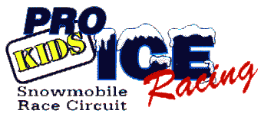
Parents & Racers
2021/2022 CODE OF CONDUCT

To ensure that KIDS PRO ICE Racing events are healthy and positive, this Code of Conduct sets forth conditions that parents and racers representing this association are expected to follow and promote. It is our intent to have KIDS PRO ICE represented in a positive manner with sportsmanship and fair play guiding all our races on the track and in the pits. In the event that parents or racers cannot or will not uphold these conditions, those parents and/or racers could face suspensions from KIDS PRO ICE racing events by the officers of this club.

- Parents and racers will conduct themselves in a manner that represents good sportsmanship and fair play at all times. Fair play is defined as the following:
  - Be knowledgeable of KIDS PRO ICE rules and regulations, and follow them.
  - Do not deliberately cut off or run into other racers during hot laps or races.
  - Promote good sportsmanship by both parents and racers.
- Parents and racers must refrain from foul language at all times.
- Parents and racers will be equally representative of good sportsmanship in winning and losing.
- Parents and racers will treat all equipment (theirs and others) in the proper manner.
- Parents and racers will not show or exhibit derogatory conduct toward any race official before, during or after the race.
- Parents will make sure all racers have proper safety equipment on machines and the racers themselves.

In conclusion, KIDS PRO ICE would like to thank all families in advance for helping make this 2021/2022 race season another great success for the group and all the racers. Without the support of everyone we would not be the “Greatest youth racing club in Minnesota”. Remember, parents build the foundation for the success of our youth and it is the intention of KIDS PRO ICE to remain the leader in youth racing.

Parents Signature ___________________________________________________

Racers Signature ___________________________________________________

